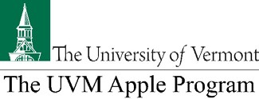
124th Annual VTFGA Meeting & Educational Program
Thursday, February 13, 2020
American Legion Hall, 49 Wilson Rd., Middlebury, VT Reduced rate, early registration deadline is February 3, 2020
Name:
Orchard/Company:
Mailing Address:
City, State, Zip:
Phone:
Email:
Meeting & Registration Fees for 2020
 | Item | Cost Calculations | Total
1. | 2018 VTFGA  Membership | - $25 for orchards under 2 acres or visiting from out of state  - $100 for orchards 5 acres or less  - $150 for orchards 5 to 50 acres  - $200 for orchards 50+ acres.
2. | Annual Meeting Registration  Early registration (must be received by Feb. 4);  Late registration (received after Feb. 4 or at door) | Per person, includes lunch  $30.00 x  $40.00 x
3. | UVM Research Support | VTFGA Directors recommend $0.005 (1/2 cent) per bushel on 2018 production  # bushels X $0.005 =
4. | U.S. Apple Association Dues | VTFGA Directors recommend $0.007 (7/10 cent) per bushel on 2018 production  # bushels X $0.007 =
5. | Total Enclosed

Make check payable to: Vermont Tree Fruit Growers Association (VTFGA) & mail to:
Mark Boyer
Vermont Tree Fruit Growers Assn.
1823 Monkton Rd.
Monkton, Vt 05469

